Passive Omnidirectional Antenna for Iridium

Certified Iridium Antenna
- Passive Antenna for Iridium terminals.
- Requires no pointing towards satellite.
- Rugged design for reliable performance in harsh conditions.
- Low loss radome.
- Mounts on 1”-14NF threaded pole.
- Coaxial cable not included.
- Our 'legacy' Iridium antenna, sold by the thousands.

ELECTRICAL SPECIFICATIONS:
FREQUENCY | 1616 - 1626.5 MHz (L-band)
SATELLITE SYSTEM | Iridium
IMPEDANCE | 50 ohm
POLARISATION | RHCP
AXIAL RATIO | < 6 dB
GAIN | 2 dBic
VSWR | < 1.5

MECHANICAL SPECIFICATIONS:
COLOR | White, non-glossy
HEIGHT | 188 mm, 191.5 mm including base
DIAMETER | 95 mm
MOUNTING | On flange 1"-14NF
OPERATING TEMPERATURE | -40C to +85C
CONNECTOR 1 | N (f)

ORDERING INFORMATION:
PART NO. | SAT-65000
PART NO. | SAT-65000

Outline Drawing
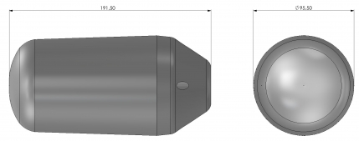

65000 Radiation pattern
